# *Spring Double Pendulum*

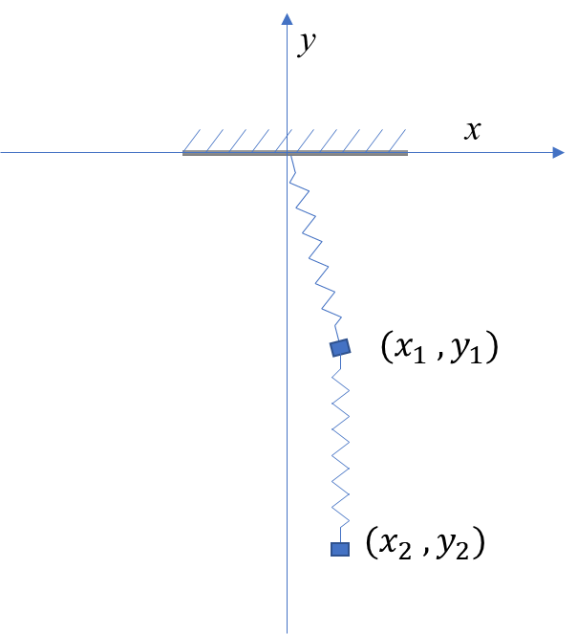

Dynamic Equations

$$m_{1}{\ddot{x}}_{1}=k\left(\sqrt{x_{1}^{2}+y_{1}^{2}}-l\right)\frac{{-x}_{1}}{\sqrt{x_{1}^{2}+y_{1}^{2}}}+k(\sqrt{{(x_{1}-x_{2})}^{2}+{(y_{1}-y_{2})}^{2}}-l)\frac{x_{2}-x_{1}}{\sqrt{{(x_{1}-x_{2})}^{2}+{(y_{1}-y_{2})}^{2}}}$$

$$m_{1}{\ddot{y}}_{1}=k\left(\sqrt{x_{1}^{2}+y_{1}^{2}}-l\right)\frac{{-y}_{1}}{\sqrt{x_{1}^{2}+y_{1}^{2}}}+k(\sqrt{{(x_{1}-x_{2})}^{2}+{(y_{1}-y_{2})}^{2}}-l)\frac{y_{2}-y_{1}}{\sqrt{{(x_{1}-x_{2})}^{2}+{(y_{1}-y_{2})}^{2}}}-m_{1}g$$

$$m_{2}{\ddot{x}}_{2}=k(\sqrt{{(x_{1}-x_{2})}^{2}+{(y_{1}-y_{2})}^{2}}-l)\frac{x_{1}-x_{2}}{\sqrt{{(x_{1}-x_{2})}^{2}+{(y_{1}-y_{2})}^{2}}}$$

$$m_{2}{\ddot{y}}_{2}=k(\sqrt{{(x_{1}-x_{2})}^{2}+{(y_{1}-y_{2})}^{2}}-l)\frac{y_{1}-y_{2}}{\sqrt{{(x_{1}-x_{2})}^{2}+{(y_{1}-y_{2})}^{2}}}-m_{2}g$$

Let $\dot{x}=v_{x}$

$${\dot{x}}_{1}=v_{x1}$$

$${\dot{y}}_{1}=v_{y1}$$

$${\dot{x}}_{2}=v_{x2}$$

$${\dot{y}}_{2}=v_{y2}$$

$$m_{1}{\dot{v}}_{x1}=k\left(\sqrt{x_{1}^{2}+y_{1}^{2}}-l\right)\frac{{-x}_{1}}{\sqrt{x_{1}^{2}+y_{1}^{2}}}+k(\sqrt{{(x_{1}-x_{2})}^{2}+{(y_{1}-y_{2})}^{2}}-l)\frac{x_{2}-x_{1}}{\sqrt{{(x_{1}-x_{2})}^{2}+{(y_{1}-y_{2})}^{2}}}$$

$$m_{1}{\dot{v}}_{y1}=k\left(\sqrt{x_{1}^{2}+y_{1}^{2}}-l\right)\frac{{-y}_{1}}{\sqrt{x_{1}^{2}+y_{1}^{2}}}+k(\sqrt{{(x_{1}-x_{2})}^{2}+{(y_{1}-y_{2})}^{2}}-l)\frac{y_{2}-y_{1}}{\sqrt{{(x_{1}-x_{2})}^{2}+{(y_{1}-y_{2})}^{2}}}-m_{1}g$$

$$m_{2}{\dot{v}}_{x2}=k(\sqrt{{(x_{1}-x_{2})}^{2}+{(y_{1}-y_{2})}^{2}}-l)\frac{x_{1}-x_{2}}{\sqrt{{(x_{1}-x_{2})}^{2}+{(y_{1}-y_{2})}^{2}}}$$

$$m_{2}{\dot{v}}_{y2}=k(\sqrt{{(x_{1}-x_{2})}^{2}+{(y_{1}-y_{2})}^{2}}-l)\frac{y_{1}-y_{2}}{\sqrt{{(x_{1}-x_{2})}^{2}+{(y_{1}-y_{2})}^{2}}}-m_{2}g$$

Let all $m=1$

1 2 3 4 5 6 7 8

$$x_{1} y_{1} x_{2} y_{2} v_{x1} v_{y1} v_{x2} v_{y2}$$

Jacobi matrix













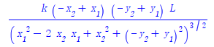

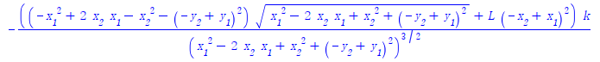

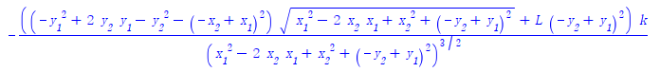



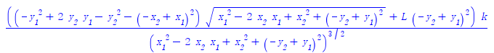

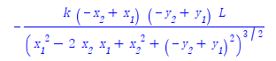

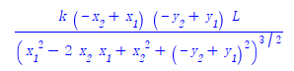



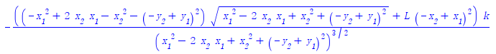

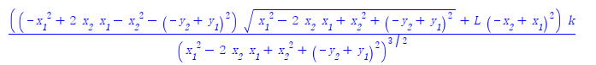

Let k=1, g=9.8, l=1

Initially

$$x_{1}=0, { y}_{1}=-1, x_{2}=0, { y}_{2}=-2$$

Calculated Equilibrium

$$x_{1}=0, { y}_{1}=-2.060, { x}_{2}=0, { y}_{2}=-3.140,$$

Jacobi matrix is

|  |  |  |  |  |  |  |  |
| --- | --- | --- | --- | --- | --- | --- | --- |
| 0 | 0 | 0 | 0 | 1 | 0 | 0 | 0 |
| 0 | 0 | 0 | 0 | 0 | 1 | 0 | 0 |
| 0 | 0 | 0 | 0 | 0 | 0 | 1 | 0 |
| 0 | 0 | 0 | 0 | 0 | 0 | 0 | 1 |
| -1.86 | 0 | 0.907 | 0 | 0 | 0 | 0 | 0 |
| 0 | -2 | 0 | 1 | 0 | 0 | 0 | 0 |
| 0.907 | 0 | -0.91 | 0 | 0 | 0 | 0 | 0 |
| 0 | 1 | 0 | -1 | 0 | 0 | 0 | 0 |

Eigenvalues are

-4.27115083e-17+0.61803399j

-4.27115083e-17-0.61803399j

1.05753171e-16+1.61803399j

1.05753171e-16-1.61803399j

1.61410528e-16+1.5516723j

1.61410528e-16-1.5516723j

-1.41036385e-17+0.59881901j

-1.41036385e-17-0.59881901j